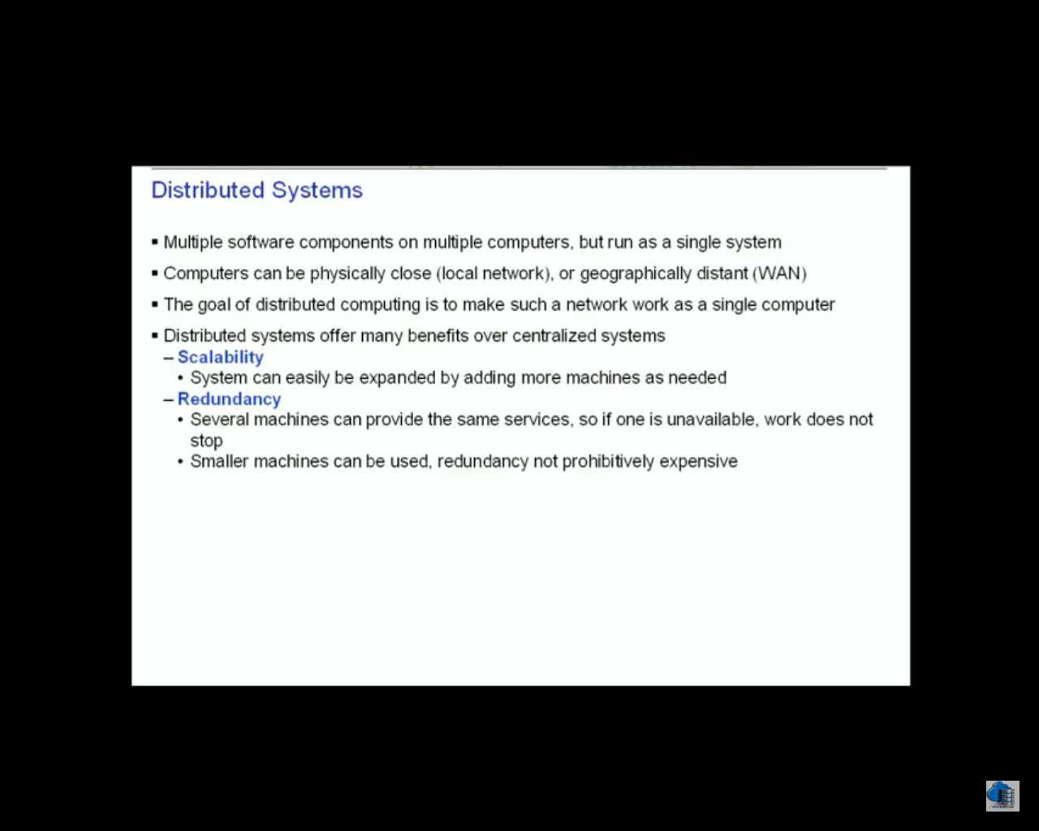

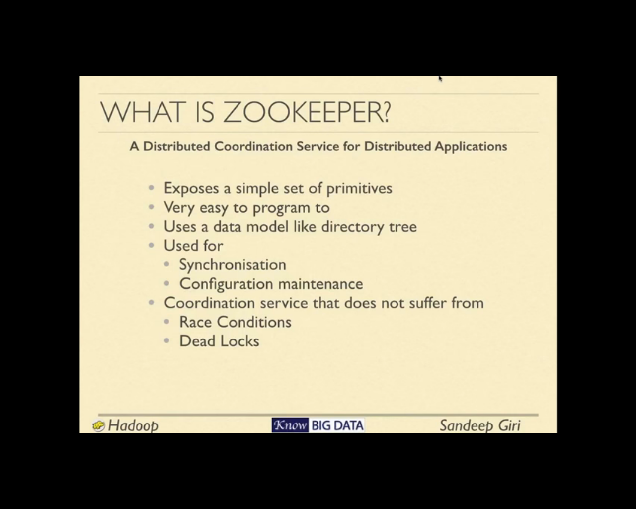

Thread synchronization good when only one process (JVM) is running

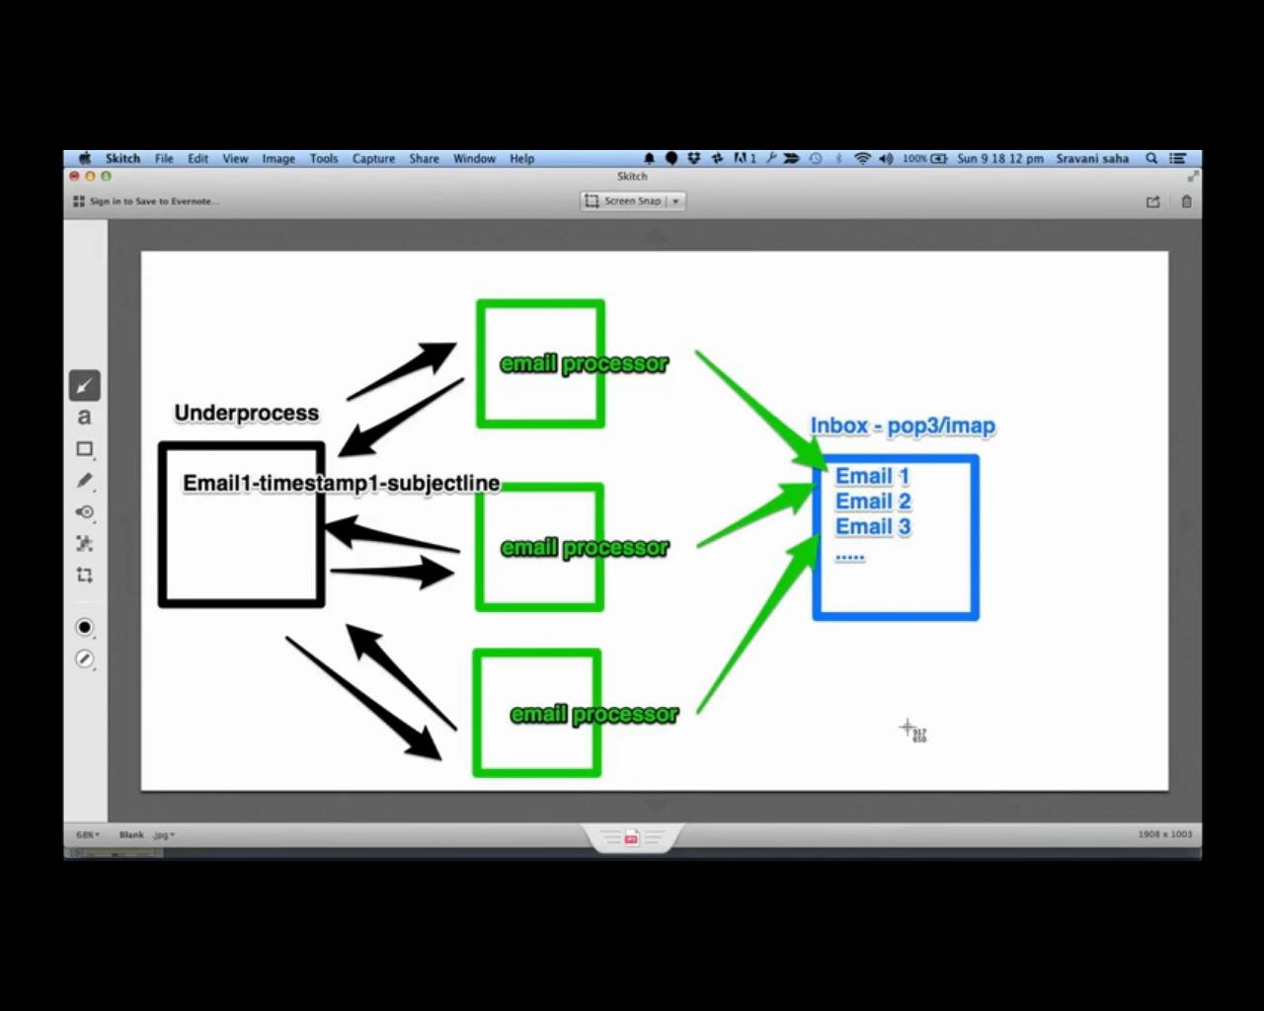

Distributed coordination service

Low latency – response in quick time

Zookeeper is Distributed coordination service for distributed application

RACE Condition -

Two parallel processes can corrupt the data

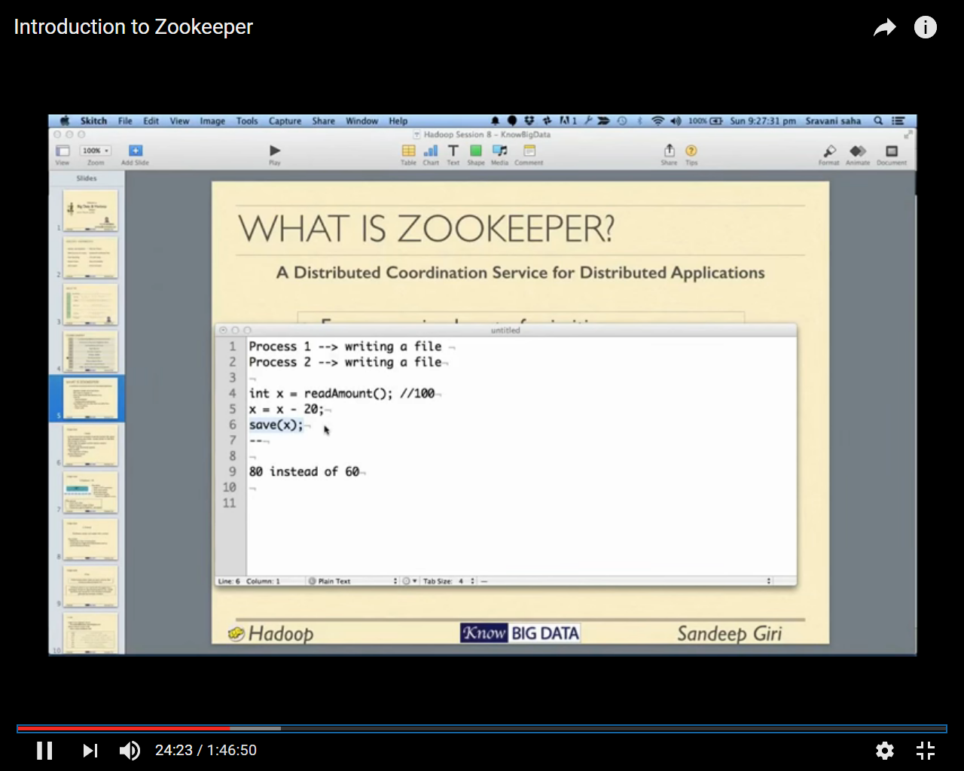

Withdrawing 20 from two ATM machine

If code is running one JVM we can control it but if it is running in two parallel jvm we cannot control it using java

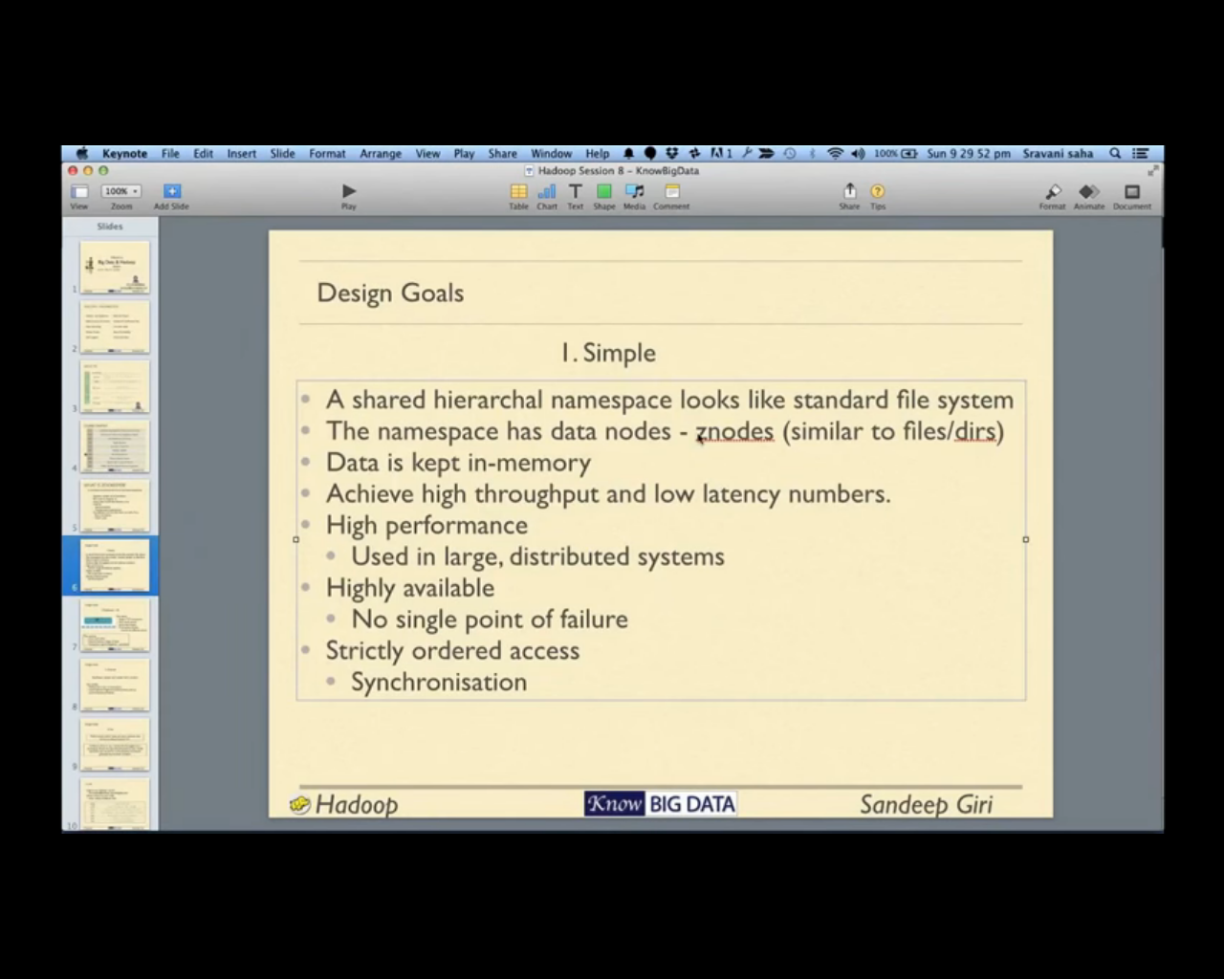

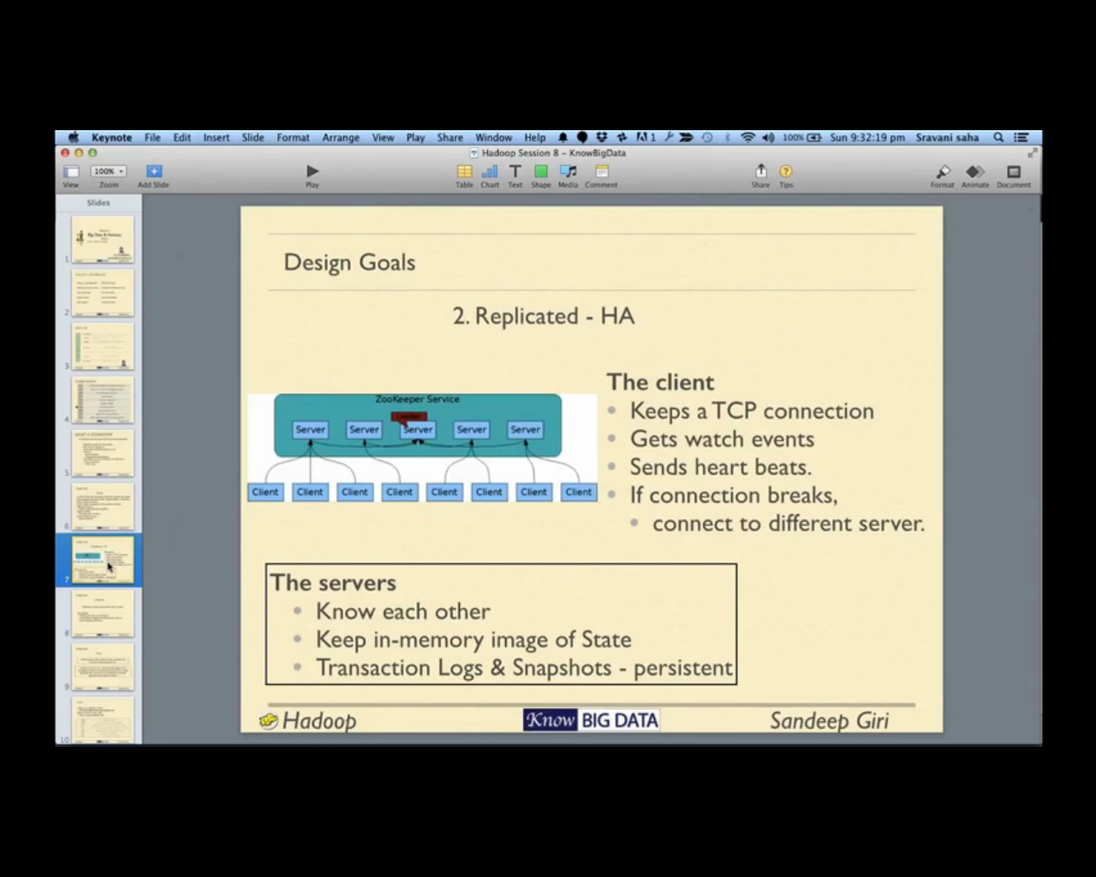

Client connected to the zookeeper service and makes a connection with one of the zookeeper service

Client periodically sends heart beat to the zookeeper service it connected with, by that mean zookeeper service know that these clients are connected , in case client goes down the connection with zookeeper to client breaks,

Other scenario could be if a client connected to a zookeeper service and zookeeper’s machine goes down in this case automatically the client is connected to another zookeeper service

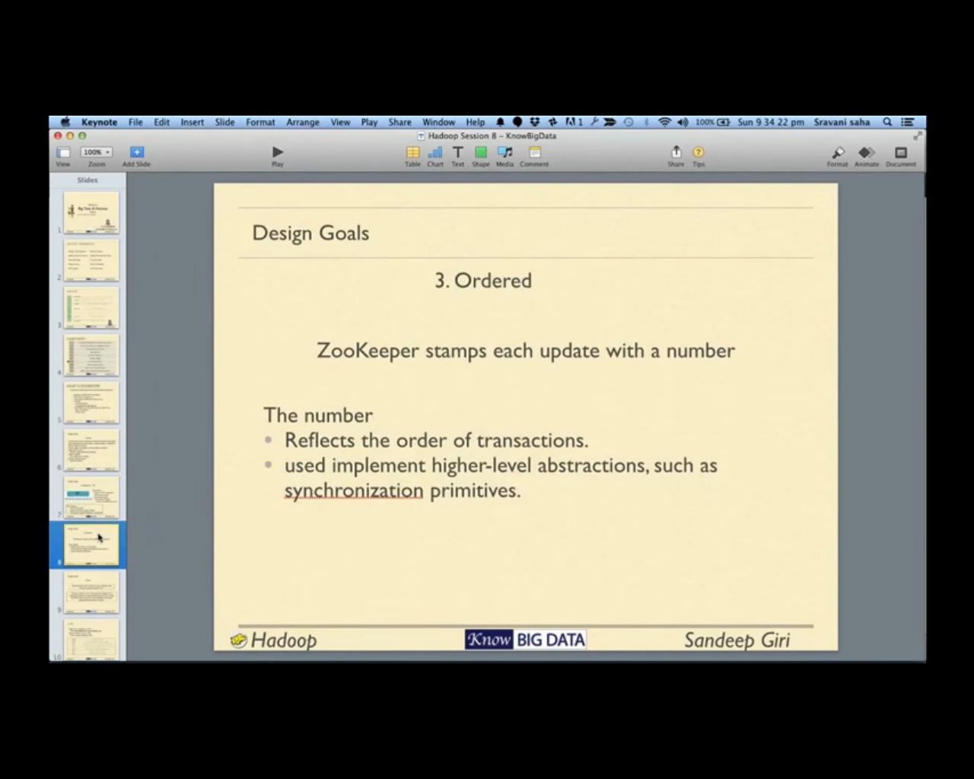

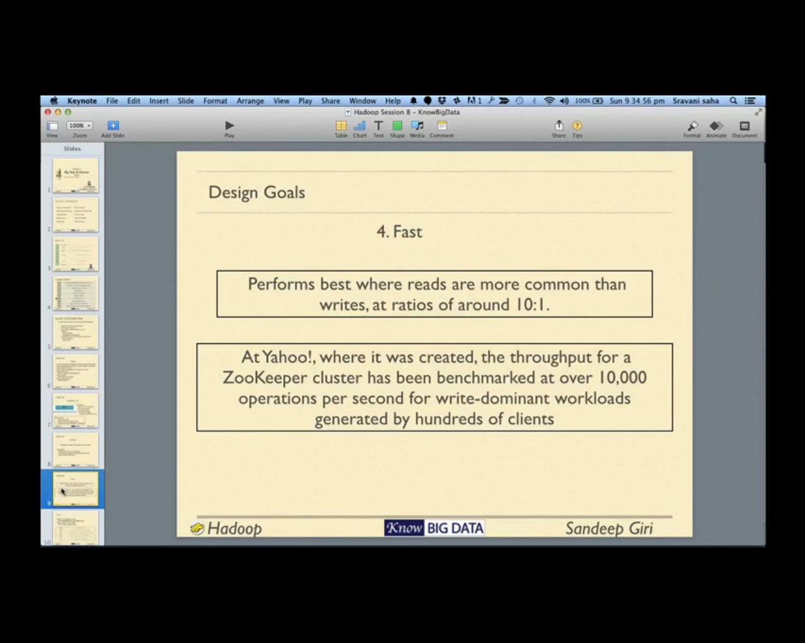

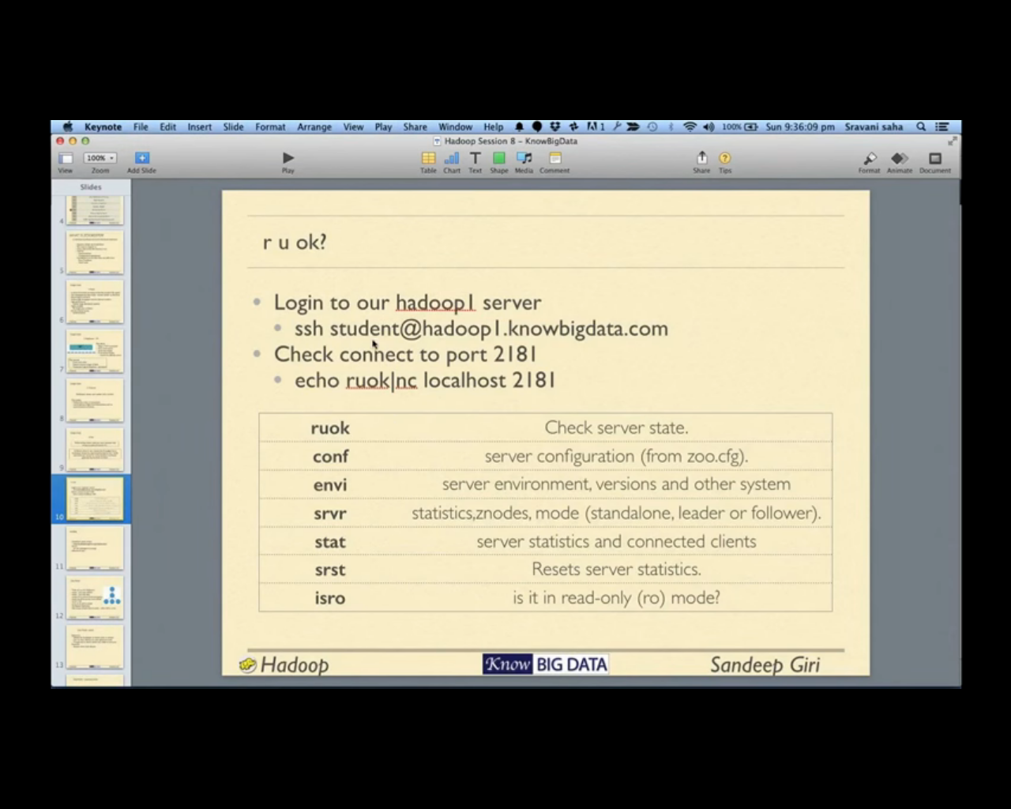

To check if zookeeper is connected run below command

# echo ruok | nc 172.27.155.55 2181

It returns imok

|  |
| --- |
| [root@mac55 version-2]# echo ruok | nc 172.27.155.55 2181  imok[root@mac55 version-2]# |

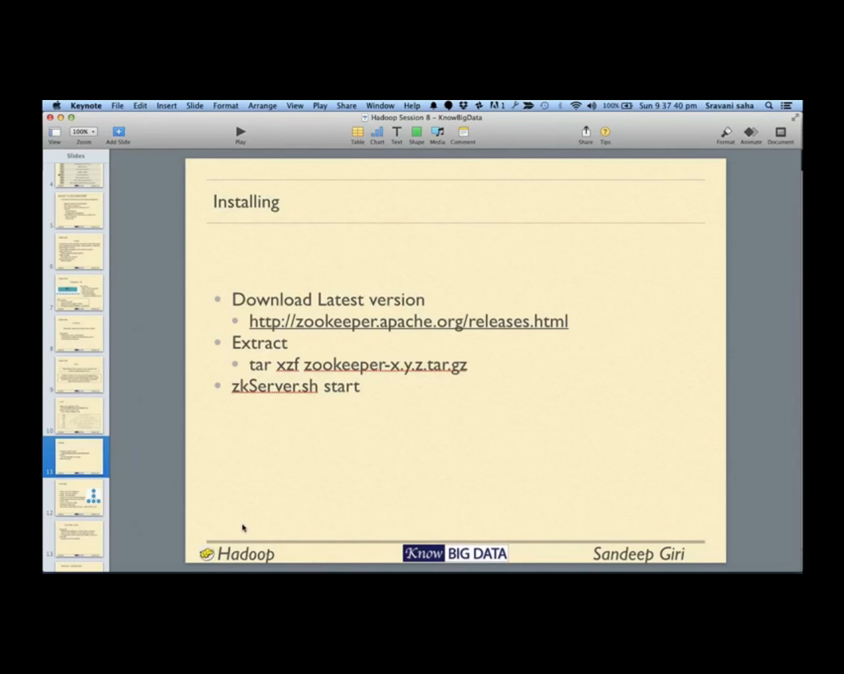

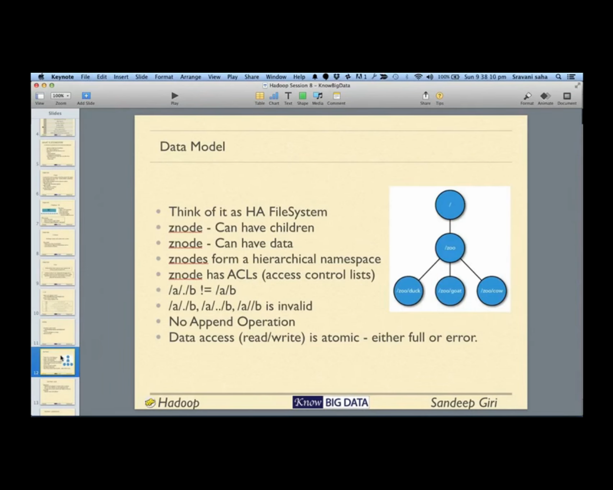

Each node can have children as well each node can save data in it

Run zookeeper client using below command

#zookeeper-client

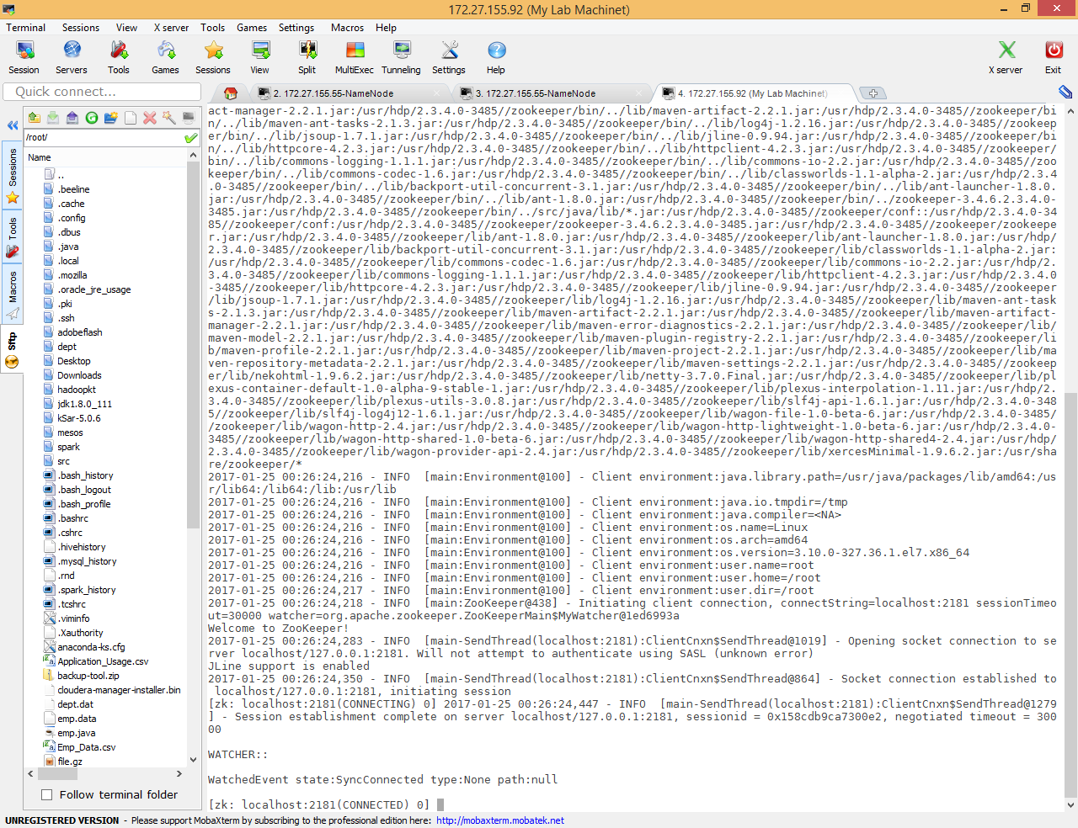

# ls / command list all the znodes which are at the top level

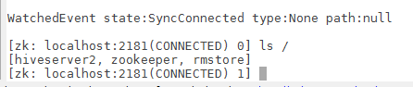

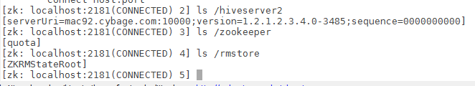

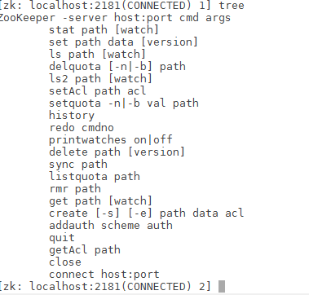

Tree command to see the different commands

get /hiveserver2 give the data under particular znode

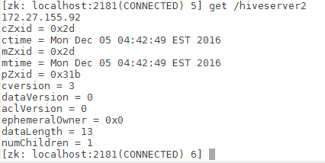

Here only data is stored is IP (172.27.155.92)

|  |
| --- |
| [zk: localhost:2181(CONNECTED) 7] get /rmstore  null  cZxid = 0x11  ctime = Mon Dec 05 03:25:23 EST 2016  mZxid = 0x11  mtime = Mon Dec 05 03:25:23 EST 2016  pZxid = 0x12  cversion = 1  dataVersion = 0  aclVersion = 0  ephemeralOwner = 0x0  dataLength = 0  numChildren = 1 |

No data store in rmstore znode

We can create data node and add some data in it

|  |
| --- |
| [zk: localhost:2181(CONNECTED) 8] create /shalaj "shalaj,anuj,ayush"  Created /shalaj  [zk: localhost:2181(CONNECTED) 9] ls /shalaj # znode shalaj do not have any furher data nodes  []  [zk: localhost:2181(CONNECTED) 10] get /shalaj  "shalaj,anuj,ayush"  cZxid = 0x524  ctime = Wed Jan 25 00:37:42 EST 2017  mZxid = 0x524  mtime = Wed Jan 25 00:37:42 EST 2017  pZxid = 0x524  cversion = 0  dataVersion = 0  aclVersion = 0  ephemeralOwner = 0x0  dataLength = 19  numChildren = 0 |

We can set the data also

|  |
| --- |
| [zk: localhost:2181(CONNECTED) 14] set /shalaj "shalajShukla"  cZxid = 0x524  ctime = Wed Jan 25 00:37:42 EST 2017  mZxid = 0x525  mtime = Wed Jan 25 00:40:56 EST 2017  pZxid = 0x524  cversion = 0  dataVersion = 1  aclVersion = 0  ephemeralOwner = 0x0  dataLength = 14  numChildren = 0  [zk: localhost:2181(CONNECTED) 15] get /shalaj  "shalajShukla"  cZxid = 0x524  ctime = Wed Jan 25 00:37:42 EST 2017  mZxid = 0x525  mtime = Wed Jan 25 00:40:56 EST 2017  pZxid = 0x524  cversion = 0  dataVersion = 1  aclVersion = 0  ephemeralOwner = 0x0  dataLength = 14  numChildren = 0  [zk: localhost:2181(CONNECTED) 16] |

Using delete command you can delete znode

|  |
| --- |
| [zk: localhost:2181(CONNECTED) 20] create /shalaj "shalaj,anuj,ayush"  Created /shalaj  [zk: localhost:2181(CONNECTED) 21] ls /  [hiveserver2, zookeeper, shalaj, rmstore]  [zk: localhost:2181(CONNECTED) 22] delete /shalaj  [zk: localhost:2181(CONNECTED) 23] ls /  [hiveserver2, zookeeper, rmstore]  [zk: localhost:2181(CONNECTED) 24] |

We cannot update the value either delete or set

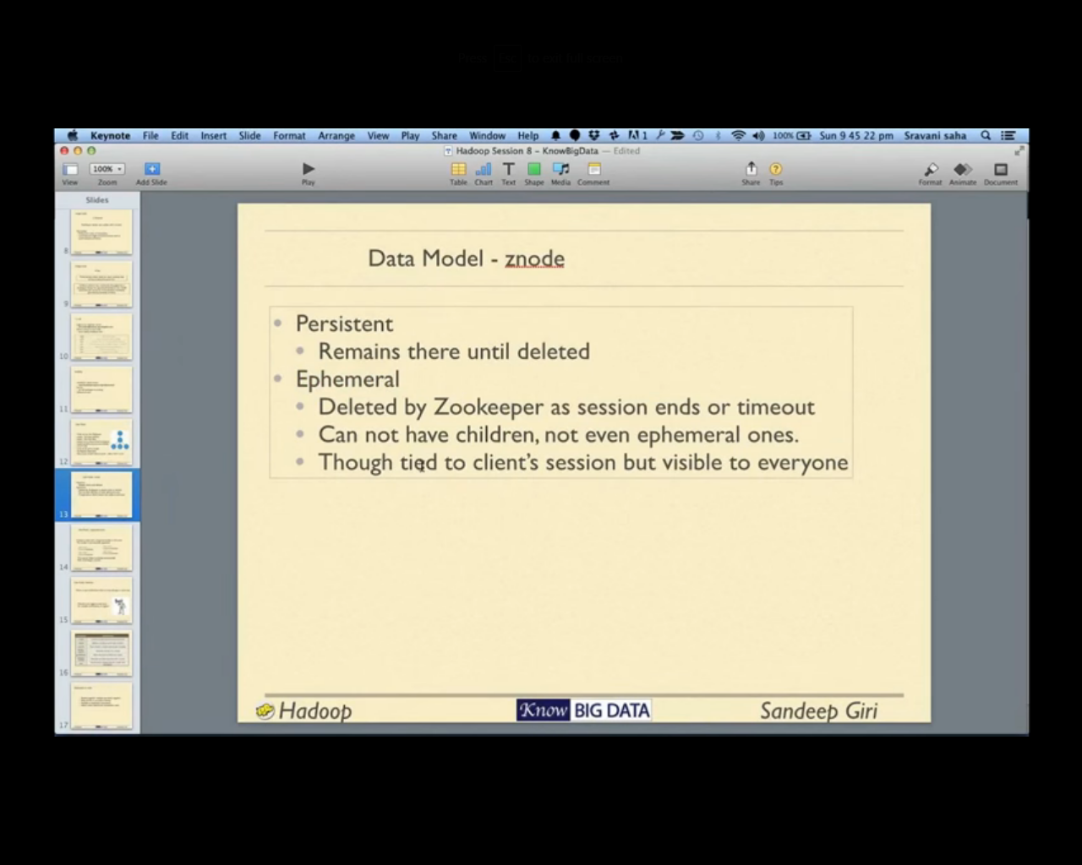

By default Persistent

Use –e option to create Ephemeral node after exiting and check znode list in some time ,it is deleted

|  |
| --- |
| [zk: localhost:2181(CONNECTED) 24] create -e /shalaj 1  Created /shalaj  [zk: localhost:2181(CONNECTED) 25] get /shalaj  1  cZxid = 0x52a  ctime = Wed Jan 25 00:48:15 EST 2017  mZxid = 0x52a  mtime = Wed Jan 25 00:48:15 EST 2017  pZxid = 0x52a  cversion = 0  dataVersion = 0  aclVersion = 0  ephemeralOwner = 0x158cdb9ca7300e2  dataLength = 1  numChildren = 0  [zk: localhost:2181(CONNECTED) 26] |

|  |
| --- |
| [root@mac92 ~]# zookeeper-client  Connecting to localhost:2181  2017-01-25 00:48:44,602 - INFO [main:Environment@100] - Client environment:zookeeper.version=3.4.6-3485--1, built on 12/16/2015 02:35 GMT  2017-01-25 00:48:44,604 - INFO [main:Environment@100] - Client environment:host.name=mac92.cybage.com  2017-01-25 00:48:44,604 - INFO [main:Environment@100] - Client environment:java.version=1.8.0_60  2017-01-25 00:48:44,606 - INFO [main:Environment@100] - Client environment:java.vendor=Oracle Corporation  2017-01-25 00:48:44,606 - INFO [main:Environment@100] - Client environment:java.home=/usr/jdk64/jdk1.8.0_60/jre  2017-01-25 00:48:44,606 - INFO [main:Environment@100] - Client environment:java.class.path=/usr/hdp/2.3.4.0-3485//zookeeper/bin/../build/classes:/usr/hdp/2.3.4.0-3485//zookeeper/bin/../build/lib/*.jar:/usr/hdp/2.3.4.0-3485//zookeeper/bin/../lib/xercesMinimal-1.9.6.2.jar:/usr/hdp/2.3.4.0-3485//zookeeper/bin/../lib/wagon-provider-api-2.4.jar:/usr/hdp/2.3.4.0-3485//zookeeper/bin/../lib/wagon-http-shared4-2.4.jar:/usr/hdp/2.3.4.0-3485//zookeeper/bin/../lib/wagon-http-shared-1.0-beta-6.jar:/usr/hdp/2.3.4.0-3485//zookeeper/bin/../lib/wagon-http-lightweight-1.0-beta-6.jar:/usr/hdp/2.3.4.0-3485//zookeeper/bin/../lib/wagon-http-2.4.jar:/usr/hdp/2.3.4.0-3485//zookeeper/bin/../lib/wagon-file-1.0-beta-6.jar:/usr/hdp/2.3.4.0-3485//zookeeper/bin/../lib/slf4j-log4j12-1.6.1.jar:/usr/hdp/2.3.4.0-3485//zookeeper/bin/../lib/slf4j-api-1.6.1.jar:/usr/hdp/2.3.4.0-3485//zookeeper/bin/../lib/plexus-utils-3.0.8.jar:/usr/hdp/2.3.4.0-3485//zookeeper/bin/../lib/plexus-interpolation-1.11.jar:/usr/hdp/2.3.4.0-3485//zookeeper/bin/../lib/plexus-container-default-1.0-alpha-9-stable-1.jar:/usr/hdp/2.3.4.0-3485//zookeeper/bin/../lib/netty-3.7.0.Final.jar:/usr/hdp/2.3.4.0-3485//zookeeper/bin/../lib/nekohtml-1.9.6.2.jar:/usr/hdp/2.3.4.0-3485//zookeeper/bin/../lib/maven-settings-2.2.1.jar:/usr/hdp/2.3.4.0-3485//zookeeper/bin/../lib/maven-repository-metadata-2.2.1.jar:/usr/hdp/2.3.4.0-3485//zookeeper/bin/../lib/maven-project-2.2.1.jar:/usr/hdp/2.3.4.0-3485//zookeeper/bin/../lib/maven-profile-2.2.1.jar:/usr/hdp/2.3.4.0-3485//zookeeper/bin/../lib/maven-plugin-registry-2.2.1.jar:/usr/hdp/2.3.4.0-3485//zookeeper/bin/../lib/maven-model-2.2.1.jar:/usr/hdp/2.3.4.0-3485//zookeeper/bin/../lib/maven-error-diagnostics-2.2.1.jar:/usr/hdp/2.3.4.0-3485//zookeeper/bin/../lib/maven-artifact-manager-2.2.1.jar:/usr/hdp/2.3.4.0-3485//zookeeper/bin/../lib/maven-artifact-2.2.1.jar:/usr/hdp/2.3.4.0-3485//zookeeper/bin/../lib/maven-ant-tasks-2.1.3.jar:/usr/hdp/2.3.4.0-3485//zookeeper/bin/../lib/log4j-1.2.16.jar:/usr/hdp/2.3.4.0-3485//zookeeper/bin/../lib/jsoup-1.7.1.jar:/usr/hdp/2.3.4.0-3485//zookeeper/bin/../lib/jline-0.9.94.jar:/usr/hdp/2.3.4.0-3485//zookeeper/bin/../lib/httpcore-4.2.3.jar:/usr/hdp/2.3.4.0-3485//zookeeper/bin/../lib/httpclient-4.2.3.jar:/usr/hdp/2.3.4.0-3485//zookeeper/bin/../lib/commons-logging-1.1.1.jar:/usr/hdp/2.3.4.0-3485//zookeeper/bin/../lib/commons-io-2.2.jar:/usr/hdp/2.3.4.0-3485//zookeeper/bin/../lib/commons-codec-1.6.jar:/usr/hdp/2.3.4.0-3485//zookeeper/bin/../lib/classworlds-1.1-alpha-2.jar:/usr/hdp/2.3.4.0-3485//zookeeper/bin/../lib/backport-util-concurrent-3.1.jar:/usr/hdp/2.3.4.0-3485//zookeeper/bin/../lib/ant-launcher-1.8.0.jar:/usr/hdp/2.3.4.0-3485//zookeeper/bin/../lib/ant-1.8.0.jar:/usr/hdp/2.3.4.0-3485//zookeeper/bin/../zookeeper-3.4.6.2.3.4.0-3485.jar:/usr/hdp/2.3.4.0-3485//zookeeper/bin/../src/java/lib/*.jar:/usr/hdp/2.3.4.0-3485//zookeeper/conf::/usr/hdp/2.3.4.0-3485//zookeeper/conf:/usr/hdp/2.3.4.0-3485//zookeeper/zookeeper-3.4.6.2.3.4.0-3485.jar:/usr/hdp/2.3.4.0-3485//zookeeper/zookeeper.jar:/usr/hdp/2.3.4.0-3485//zookeeper/lib/ant-1.8.0.jar:/usr/hdp/2.3.4.0-3485//zookeeper/lib/ant-launcher-1.8.0.jar:/usr/hdp/2.3.4.0-3485//zookeeper/lib/backport-util-concurrent-3.1.jar:/usr/hdp/2.3.4.0-3485//zookeeper/lib/classworlds-1.1-alpha-2.jar:/usr/hdp/2.3.4.0-3485//zookeeper/lib/commons-codec-1.6.jar:/usr/hdp/2.3.4.0-3485//zookeeper/lib/commons-io-2.2.jar:/usr/hdp/2.3.4.0-3485//zookeeper/lib/commons-logging-1.1.1.jar:/usr/hdp/2.3.4.0-3485//zookeeper/lib/httpclient-4.2.3.jar:/usr/hdp/2.3.4.0-3485//zookeeper/lib/httpcore-4.2.3.jar:/usr/hdp/2.3.4.0-3485//zookeeper/lib/jline-0.9.94.jar:/usr/hdp/2.3.4.0-3485//zookeeper/lib/jsoup-1.7.1.jar:/usr/hdp/2.3.4.0-3485//zookeeper/lib/log4j-1.2.16.jar:/usr/hdp/2.3.4.0-3485//zookeeper/lib/maven-ant-tasks-2.1.3.jar:/usr/hdp/2.3.4.0-3485//zookeeper/lib/maven-artifact-2.2.1.jar:/usr/hdp/2.3.4.0-3485//zookeeper/lib/maven-artifact-manager-2.2.1.jar:/usr/hdp/2.3.4.0-3485//zookeeper/lib/maven-error-diagnostics-2.2.1.jar:/usr/hdp/2.3.4.0-3485//zookeeper/lib/maven-model-2.2.1.jar:/usr/hdp/2.3.4.0-3485//zookeeper/lib/maven-plugin-registry-2.2.1.jar:/usr/hdp/2.3.4.0-3485//zookeeper/lib/maven-profile-2.2.1.jar:/usr/hdp/2.3.4.0-3485//zookeeper/lib/maven-project-2.2.1.jar:/usr/hdp/2.3.4.0-3485//zookeeper/lib/maven-repository-metadata-2.2.1.jar:/usr/hdp/2.3.4.0-3485//zookeeper/lib/maven-settings-2.2.1.jar:/usr/hdp/2.3.4.0-3485//zookeeper/lib/nekohtml-1.9.6.2.jar:/usr/hdp/2.3.4.0-3485//zookeeper/lib/netty-3.7.0.Final.jar:/usr/hdp/2.3.4.0-3485//zookeeper/lib/plexus-container-default-1.0-alpha-9-stable-1.jar:/usr/hdp/2.3.4.0-3485//zookeeper/lib/plexus-interpolation-1.11.jar:/usr/hdp/2.3.4.0-3485//zookeeper/lib/plexus-utils-3.0.8.jar:/usr/hdp/2.3.4.0-3485//zookeeper/lib/slf4j-api-1.6.1.jar:/usr/hdp/2.3.4.0-3485//zookeeper/lib/slf4j-log4j12-1.6.1.jar:/usr/hdp/2.3.4.0-3485//zookeeper/lib/wagon-file-1.0-beta-6.jar:/usr/hdp/2.3.4.0-3485//zookeeper/lib/wagon-http-2.4.jar:/usr/hdp/2.3.4.0-3485//zookeeper/lib/wagon-http-lightweight-1.0-beta-6.jar:/usr/hdp/2.3.4.0-3485//zookeeper/lib/wagon-http-shared-1.0-beta-6.jar:/usr/hdp/2.3.4.0-3485//zookeeper/lib/wagon-http-shared4-2.4.jar:/usr/hdp/2.3.4.0-3485//zookeeper/lib/wagon-provider-api-2.4.jar:/usr/hdp/2.3.4.0-3485//zookeeper/lib/xercesMinimal-1.9.6.2.jar:/usr/share/zookeeper/*  2017-01-25 00:48:44,606 - INFO [main:Environment@100] - Client environment:java.library.path=/usr/java/packages/lib/amd64:/usr/lib64:/lib64:/lib:/usr/lib  2017-01-25 00:48:44,606 - INFO [main:Environment@100] - Client environment:java.io.tmpdir=/tmp  2017-01-25 00:48:44,606 - INFO [main:Environment@100] - Client environment:java.compiler=<NA>  2017-01-25 00:48:44,606 - INFO [main:Environment@100] - Client environment:os.name=Linux  2017-01-25 00:48:44,606 - INFO [main:Environment@100] - Client environment:os.arch=amd64  2017-01-25 00:48:44,606 - INFO [main:Environment@100] - Client environment:os.version=3.10.0-327.36.1.el7.x86_64  2017-01-25 00:48:44,607 - INFO [main:Environment@100] - Client environment:user.name=root  2017-01-25 00:48:44,607 - INFO [main:Environment@100] - Client environment:user.home=/root  2017-01-25 00:48:44,607 - INFO [main:Environment@100] - Client environment:user.dir=/root  2017-01-25 00:48:44,608 - INFO [main:ZooKeeper@438] - Initiating client connection, connectString=localhost:2181 sessionTimeout=30000 watcher=org.apache.zookeeper.ZooKeeperMain$MyWatcher@1ed6993a  Welcome to ZooKeeper!  2017-01-25 00:48:44,631 - INFO [main-SendThread(localhost:2181):ClientCnxn$SendThread@1019] - Opening socket connection to server localhost/0:0:0:0:0:0:0:1:2181. Will not attempt to authenticate using SASL (unknown error)  JLine support is enabled  2017-01-25 00:48:44,677 - INFO [main-SendThread(localhost:2181):ClientCnxn$SendThread@864] - Socket connection established to localhost/0:0:0:0:0:0:0:1:2181, initiating session  [zk: localhost:2181(CONNECTING) 0] 2017-01-25 00:48:44,733 - INFO [main-SendThread(localhost:2181):ClientCnxn$SendThread@1279] - Session establishment complete on server localhost/0:0:0:0:0:0:0:1:2181, sessionid = 0x158cdb9ca7300e3, negotiated timeout = 30000  WATCHER::  WatchedEvent state:SyncConnected type:None path:null  [zk: localhost:2181(CONNECTED) 0] ls /  [hiveserver2, zookeeper, rmstore]  [zk: localhost:2181(CONNECTED) 1] |

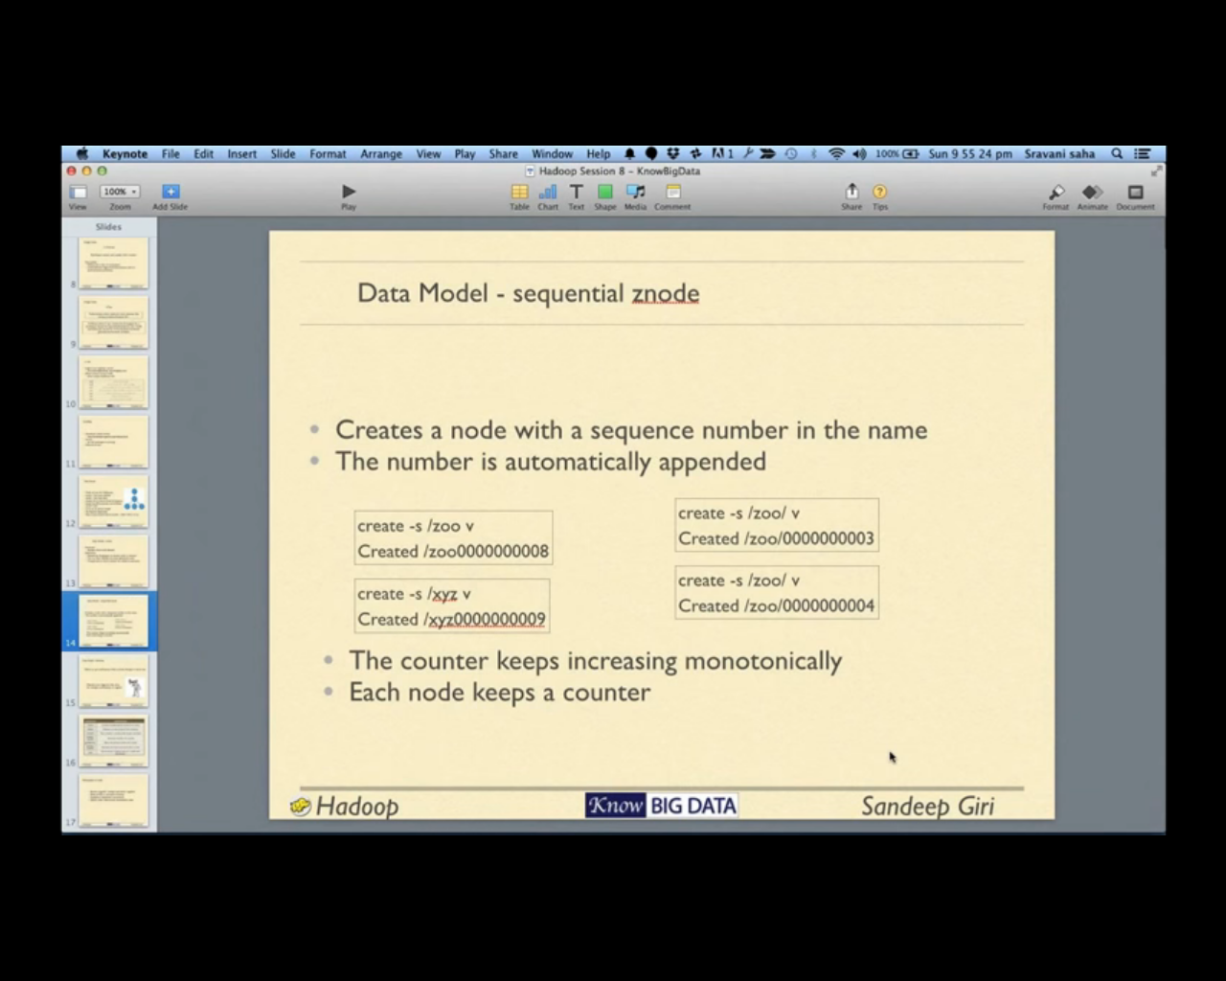

Another type of znode is sequential node we can create it using –s option, it automatically create name in a sequence , sequence is calculate per node basis for all node it start with 0000000000

|  |
| --- |
| [zk: localhost:2181(CONNECTED) 23] create -s /shalaj/ 1  Created /shalaj/0000000000  [zk: localhost:2181(CONNECTED) 24] create -s /shalaj/ 1  Created /shalaj/0000000001  [zk: localhost:2181(CONNECTED) 25] create -s /shalaj/ 1  Created /shalaj/0000000002  [zk: localhost:2181(CONNECTED) 26] ls /shalaj  [0000000001, 0000000000, 0000000002]  [zk: localhost:2181(CONNECTED) 27] |

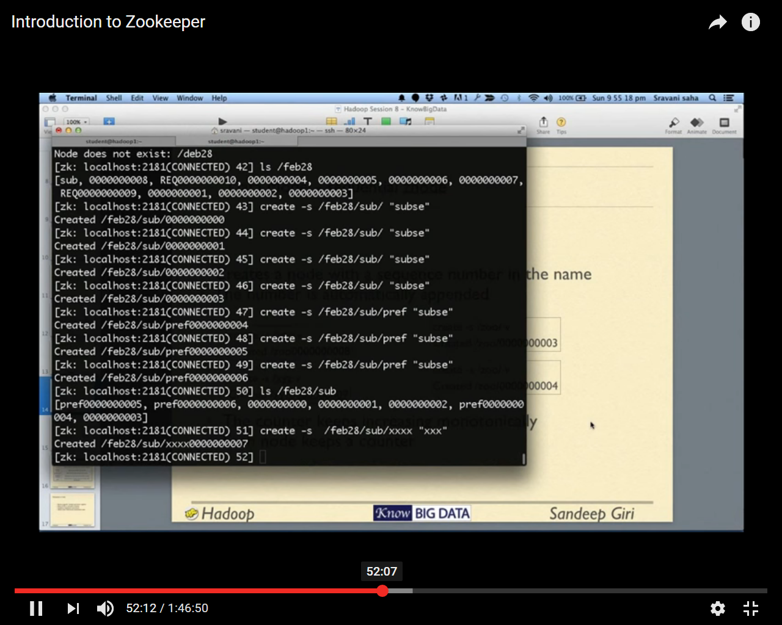

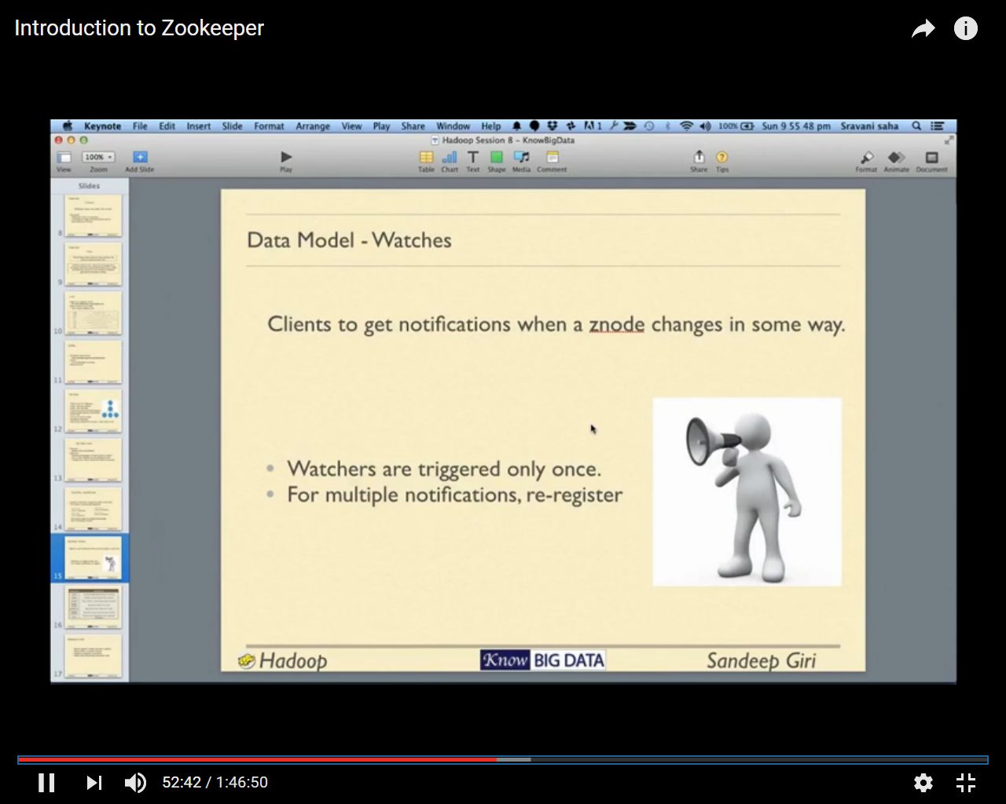

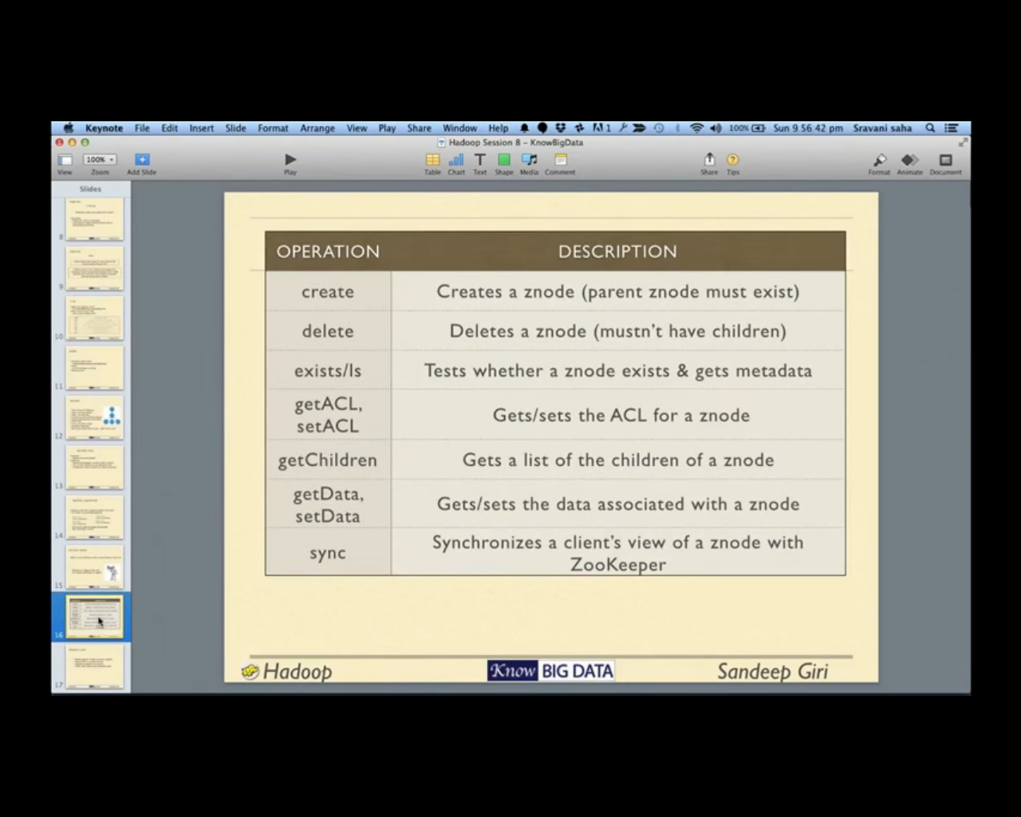

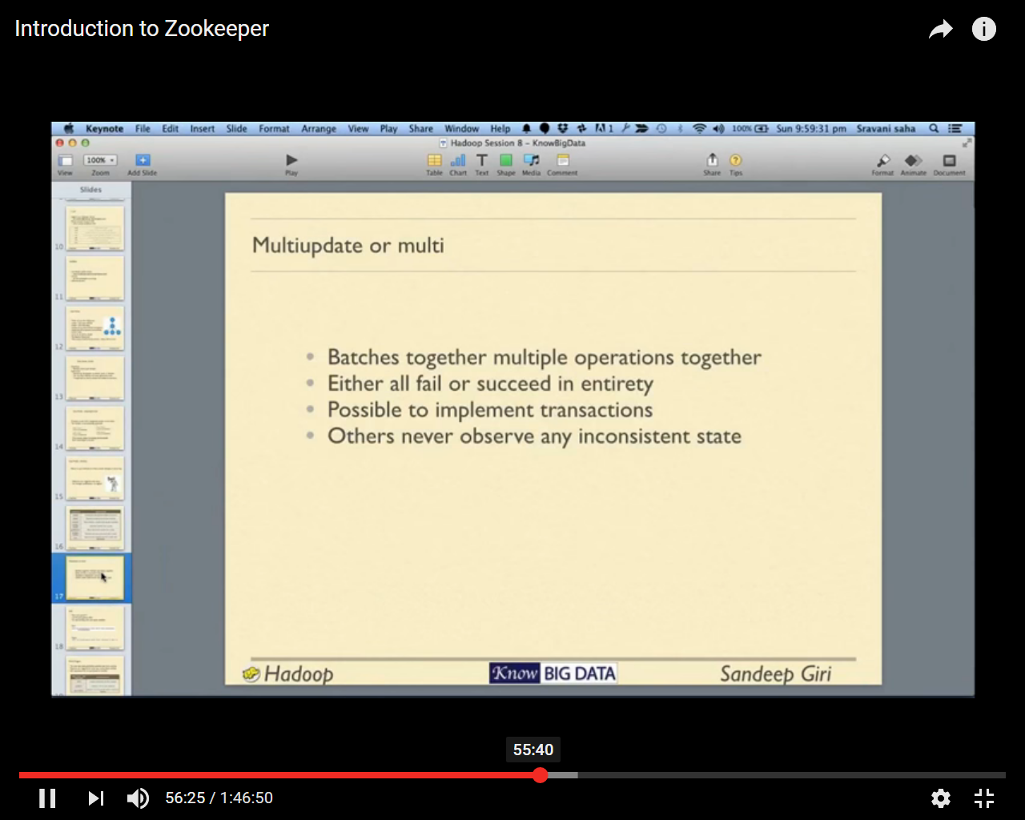

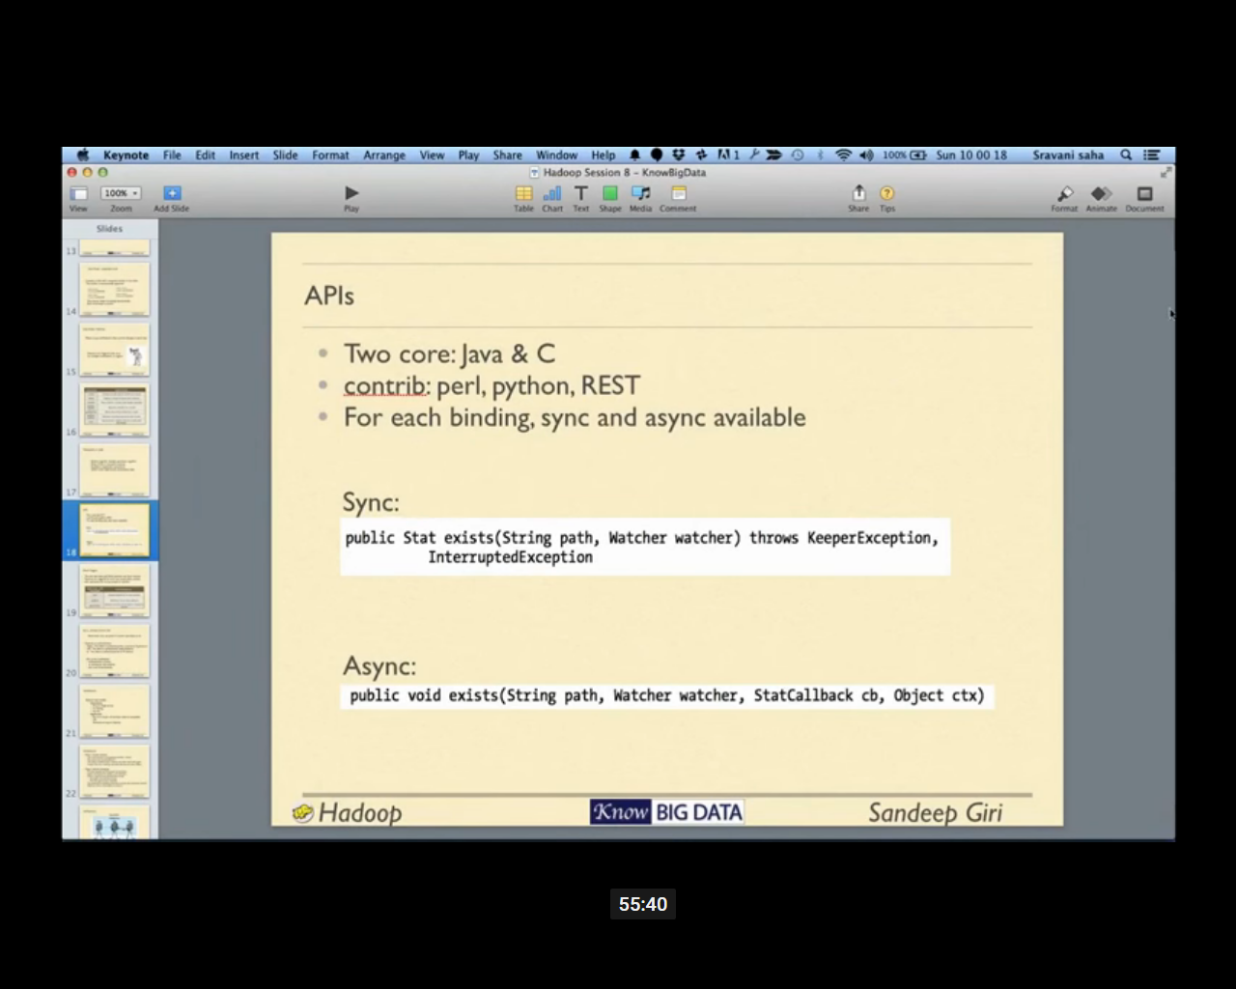

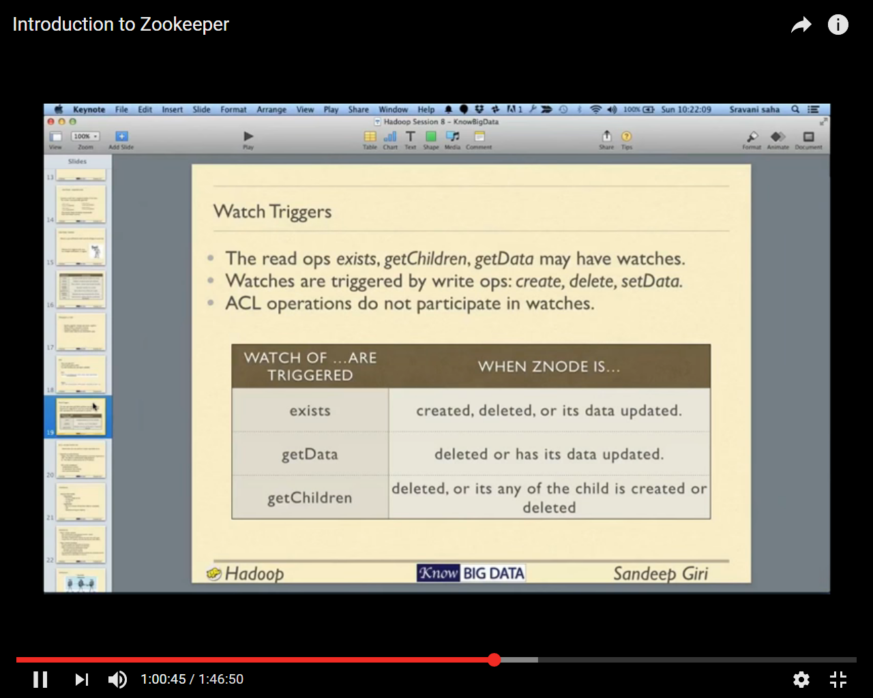

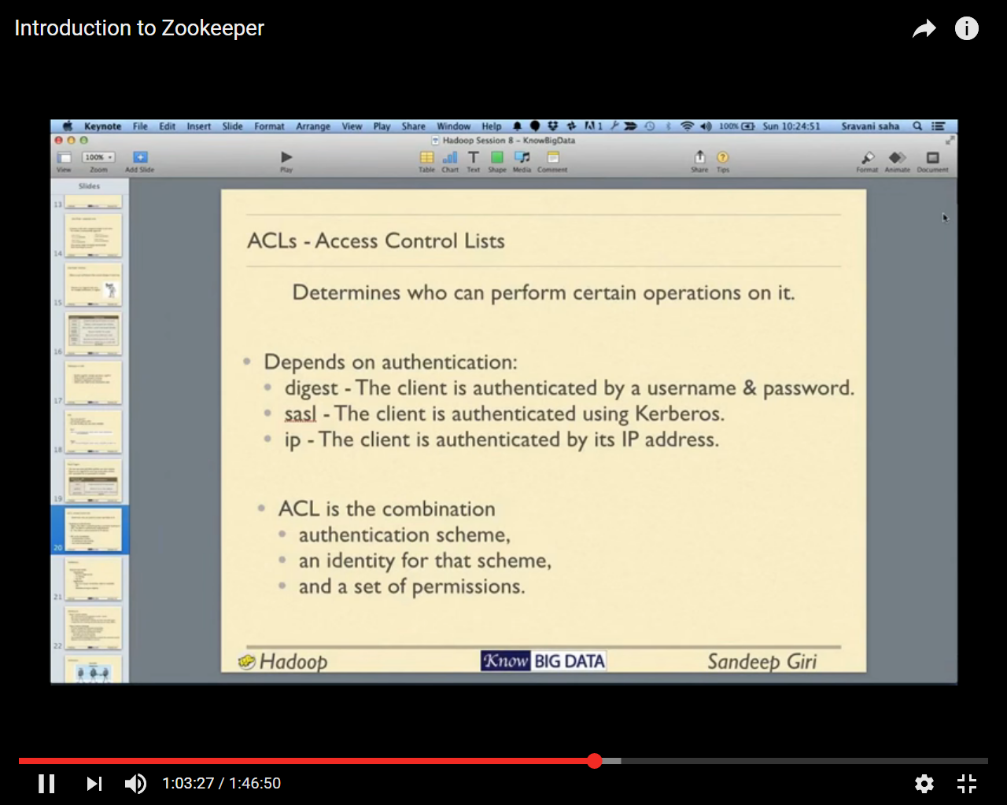

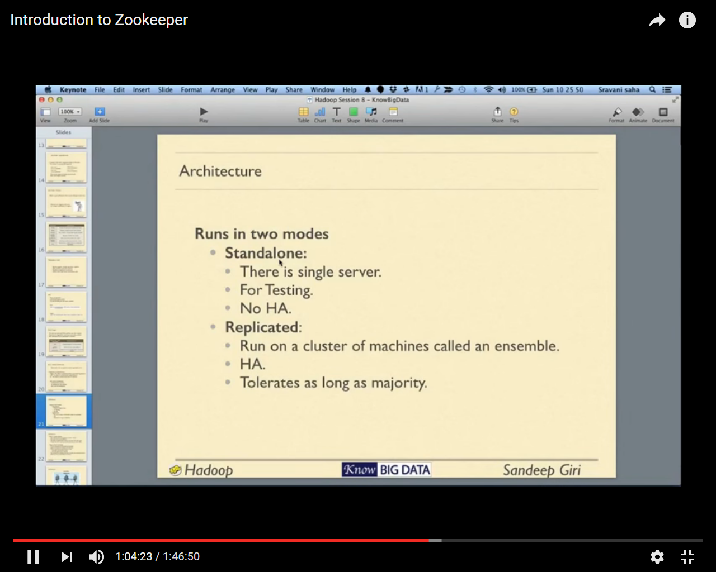

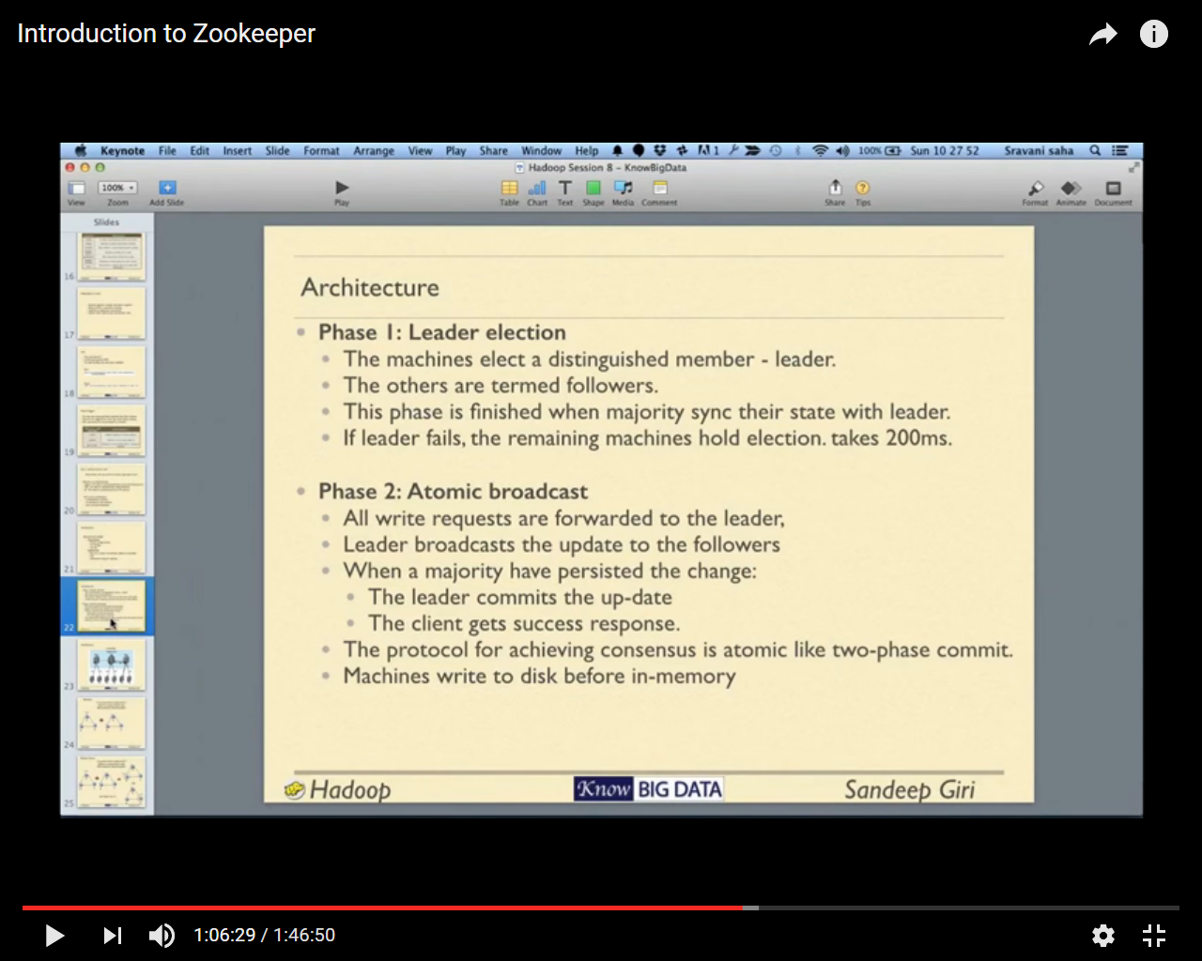

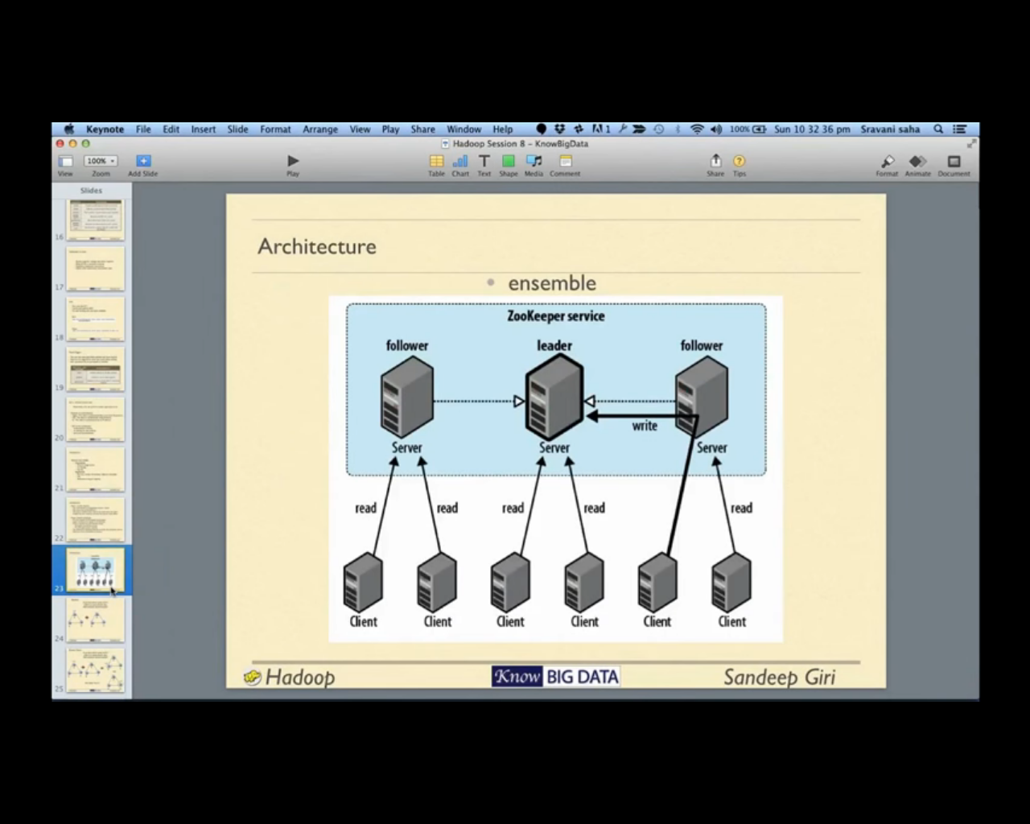

More than 50% machines should be up

Followers elect new leader based on performance the network distance from each followers etc.

Let’s say we have 3 zookeeper services

* If one machine goes down, ensemble works properly
* In case one leader goes down, one of the followers become leader based on voting and ensemble will work
* In case two follower machine goes down then leader will step down and ensemble will not work for write although read will happen properly

Write happened only on leaders node and leaders first update the same in majority of followers if success it update in its on disk and update the memory and by that way all node have same data, each write create an incremental version number, if suppose one node goes down and for few time later it become available it has some older version so it will get the remaining copy of data from node that has latest version

